DESIGN CHALLENGE: INTERACTIVE TOY
Name: Patrick Duong

Project Concept Statement:
The goal of this project is to create a mini affordable interactive fan for children. This interactive toy will rotate its fan, turn both two LEDs on, and play a song when the children interact with it. This toy should be easy to play, have user-friendly structure, and bring entertainment to the children. The toy only requires a RedBoard, a Photoresistor, 2 LEDs, a switch, 2 resistors, a buzzer, and a servo motor from Tinker Kit to be built.

Constraints
Name | Description
Digital Pins | RedBoard has 13 digital input/output pins
Analog pins | RedBoard has 6 analog input pins
Photoresistor | -Photoresistor is needed to detect when the children interact with the toy. Covering this sensor is the only way that children will interact with this toy.  -Limitation: reacts to the lights quite slowly, easy to break.
Servo Motor | -This component is needed for the ‘fan’ part of the toy.  -Limitations: if something within this motor breaks, it will unpredictably function. It can also be damaged by sustained overload.
LEDs | -Red and blue LEDs are needed to make the toy more attractive to the children. They are a required part of the toy.  -Limitation: easy to break.
Switch | -The switch is needed to activate the toy. When switch is on, the toy is ready to interact. When the switch is off, the toy is completely unable to react.  -Limitation: easy to break. Its performance gradually degrades if it is used excessively.
330Ω resistors | Resistors must be used for the LEDs to work properly.
Buzzer | -Buzzer is needed to play ‘Happy Birthday’ for the children.  -Limitation: They are usually not very loud; easy to break.

Performance Criteria
Name | Description
Consistency | The sensor, fan, LEDs, and buzzer must consistently work as programmed whenever the children interact with the toy.
Stability | The toy should endure bumps and shakes whenever the children violently interact with it.
Aesthetics | The toy should have a user-friendly structure and look nice overall.
Responsive | The system should react quickly to brightness changes on the photoresistor.
Safety | The toy must guarantee the safety of the children when they play with it.

Design Concept One:
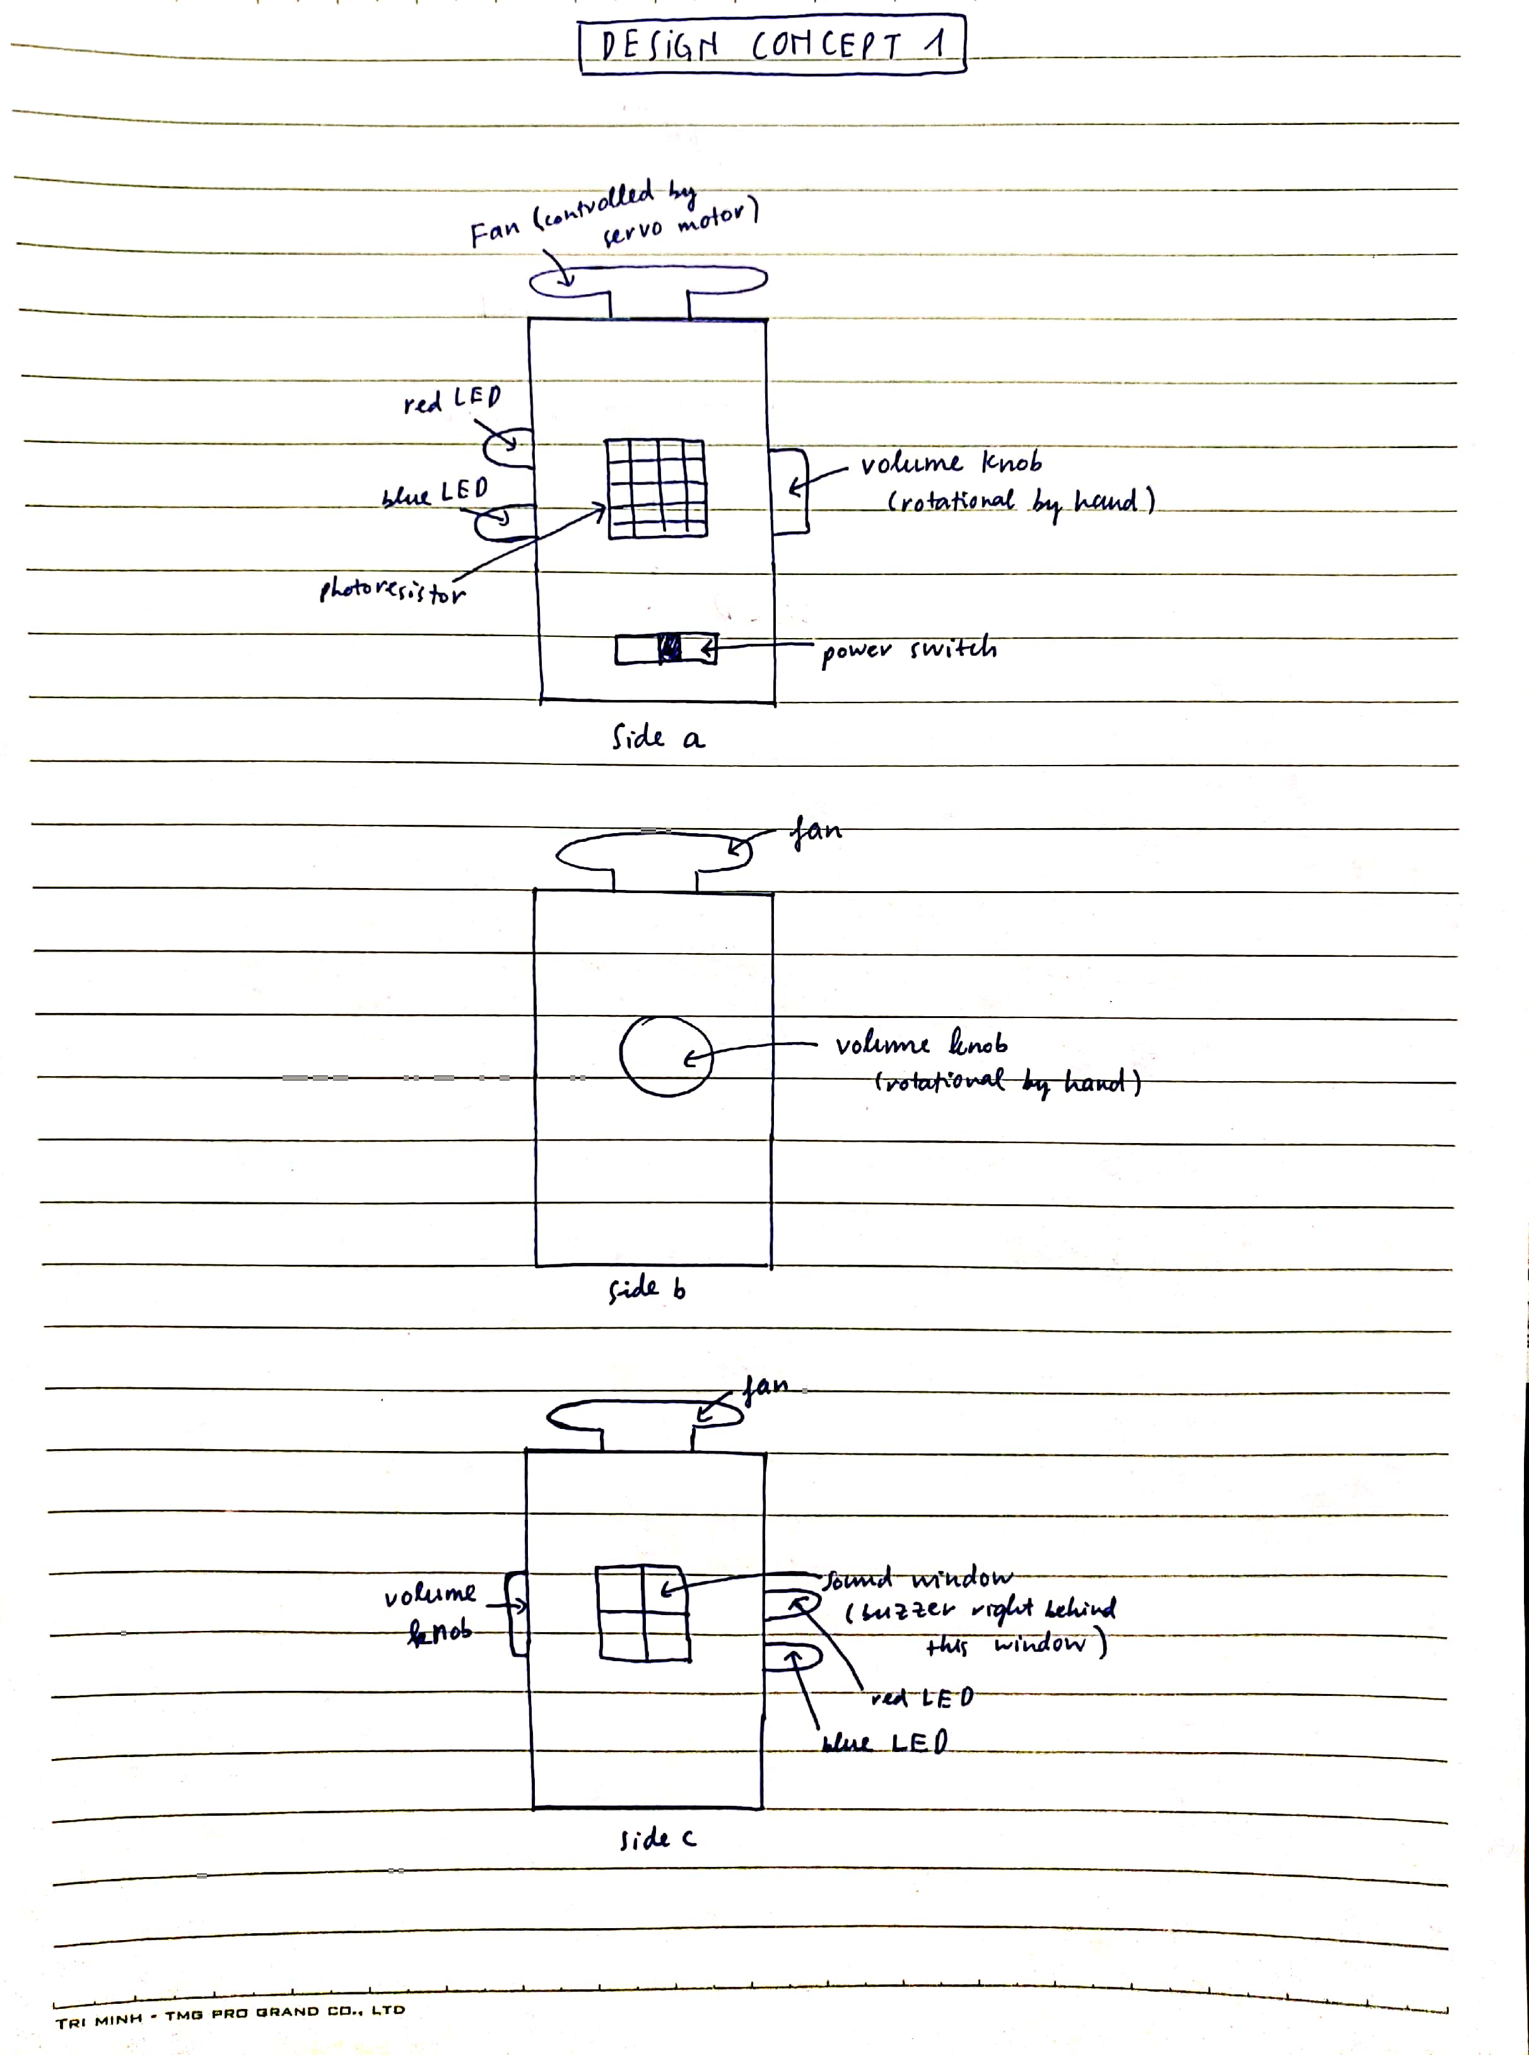
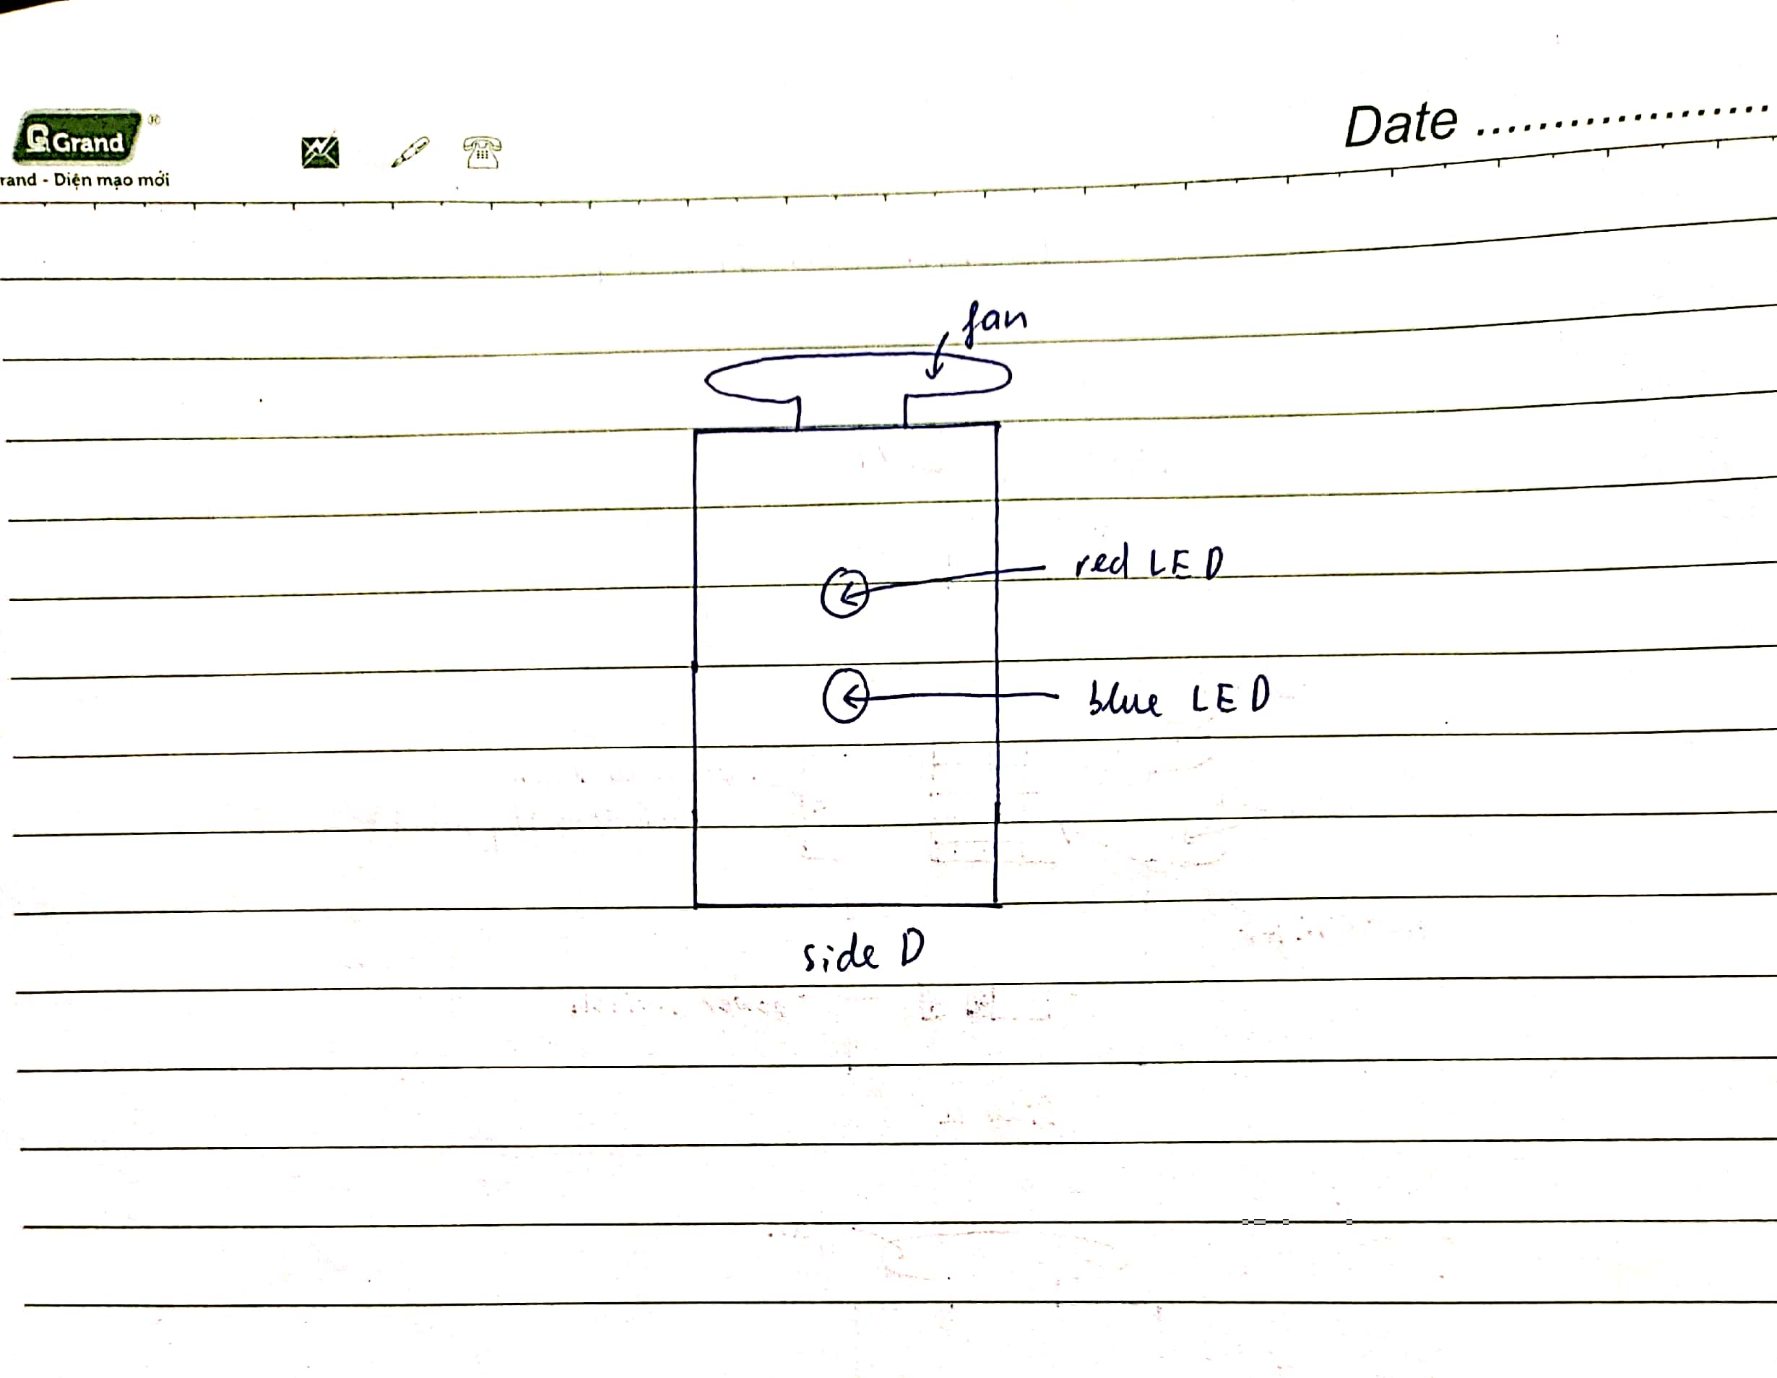
- This design has a photoresistor on its body and right below the photoresistor is the power switch. When the power switch is switched to ‘on’, the toy is ready to interact. When the power switch is at ‘off’, the toy will be turned off completely and will not be able to interact with children. There is no way for the toy to work if the power switch is ‘off’.
- When the power switch is ‘on’, if the children cover the photoresistor of the toy with their hands (or just simply bring the toy to the dark), the photoresistor will activate the fan to spin, turn the red and blue LEDs on, and trigger the buzzer inside the toy to play the ‘Happy Birthday’ song through the sound window all at the same time. The loudness of the song can be changed easily by rotating the volume knob.
- Given that the power switch is already ‘on’, whenever the children stop covering their hands over the photoresistor (or there is more brightness on the photoresistor), the fan, buzzer, and the LEDs will stop working. To get them to work again, the children just need to keep the photoresistor in the dark. If the photoresistor is continuously kept in the dark, the LEDs, fan, and buzzer will never stop working.
- In this design, all the wires are put inside the body of the toy, so the overall appearance of the toy will look nice. More importantly, the children will be safe (avoid getting electrocuted) when interacting with this toy if all its wires are hidden.
- Due to being placed on the body of the toy, the photoresistor will be able to quickly respond to the brightness changes of the environment. Moreover, with the structure of the fan on the top and all other components on the body, this toy will be able to endure bumps and shakes during its interaction with children.
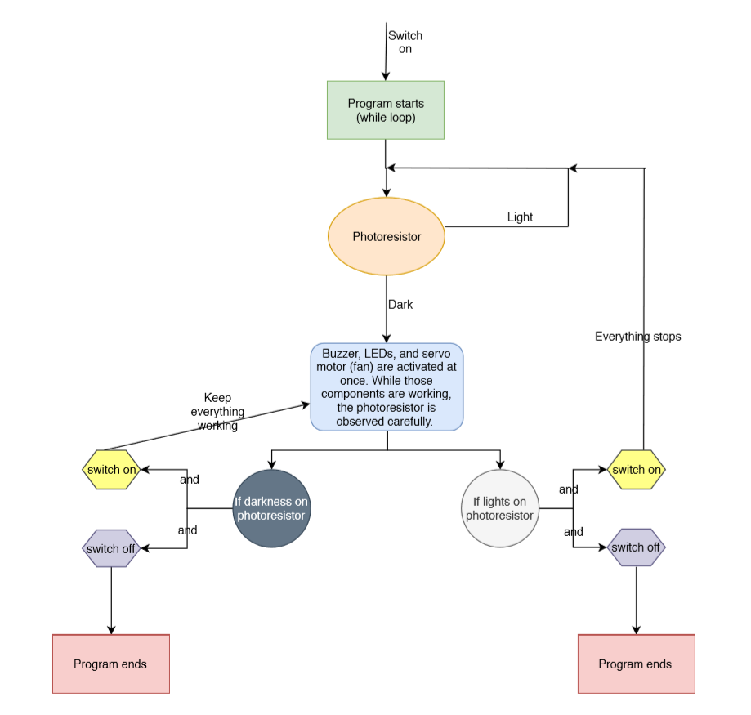
Buzzer, volume knob, LEDs, and servo motor (fan) are activated at once. While those components are working, the photoresistor is observed carefully.
(Flow chart of Design Concept 1)

Design Concept Two:
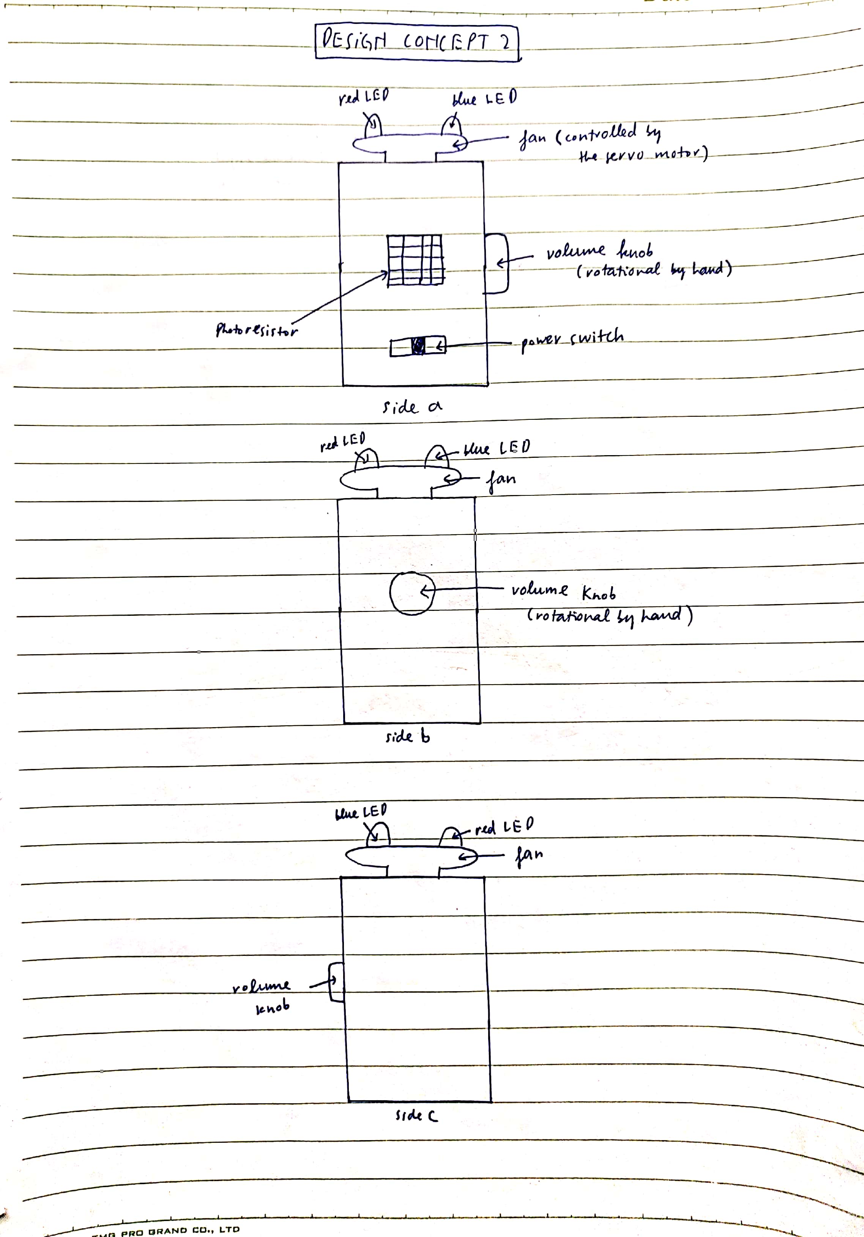

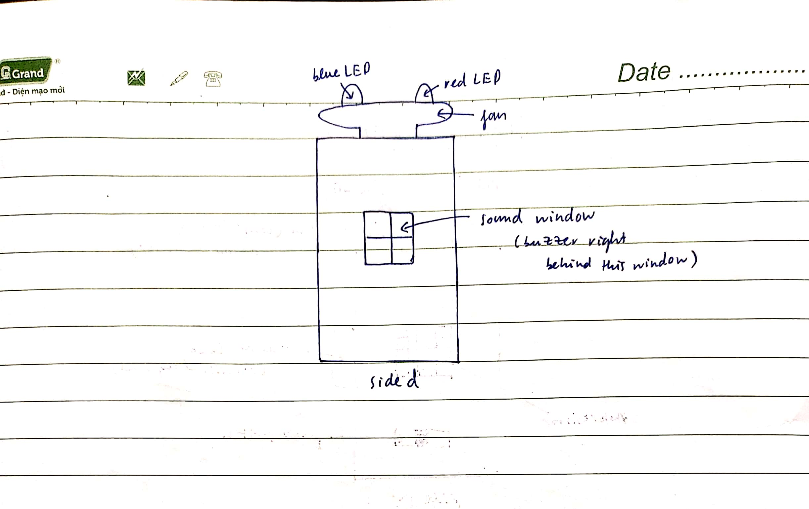
- This design has a photoresistor on its body and right below the photoresistor is the power switch. When the power switch is switched to ‘on’, the toy is ready to interact. When the power switch is at ‘off’, the toy will be turned off completely and there is no way for it to interact with the children.
- When the power switch is ‘on’, if the children cover the photoresistor of the toy with their hands (or just simply bring the toy to the dark), the photoresistor will trigger the buzzer to play the entire ‘Happy Birthday’ song first, then activate the fan to spin and the LEDs on the fan to blink at the same time. The volume knob on the toy’s body will enable the children to adjust the loudness of the song.
- Given that the power switch is already ‘on’, whenever the children stop covering their hands over the photoresistor (or there is more brightness on the photoresistor), the fan, buzzer, and the LEDs will stop working. To get them to work again, the children just need to keep the photoresistor in the dark. If the photoresistor is continuously kept in the dark, the LEDs, fan, and buzzer will never stop working.
- In this design, when the fan spins and LEDs blink simultaneously, the toy will look very attractive to the children. They can also fully enjoy the ‘Happy Birthday’ song without being distracted by the sound of the motor since the motor is supposed to work after the song is over.
- The photoresistor will be able to quickly respond to the brightness changes of the environment since it is placed on the body of the toy. In addition, with the structure of the fan on the top and all other components on the body, this toy will be able to endure shakes and bumps when interacting with children.
- Even though the wires are not completely hidden inside the toy (some need to be outside to connect the fan LEDs to the power source inside the toy), the toy is still highly safe for the children to play with.
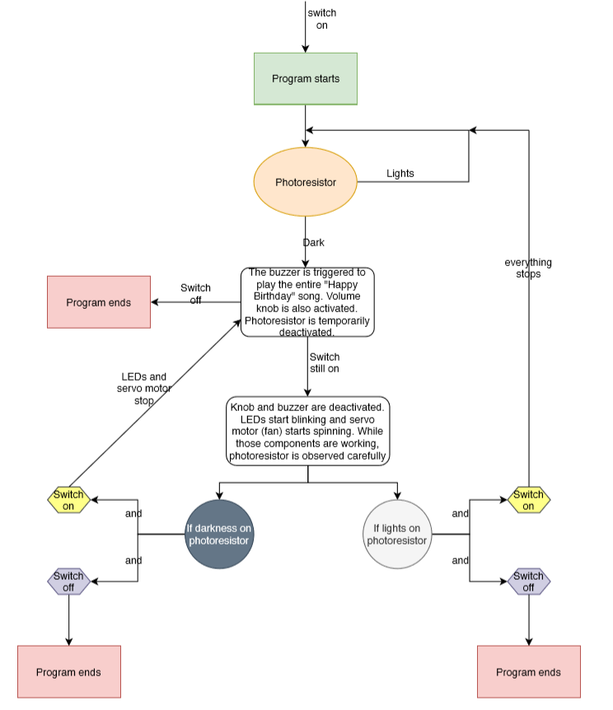

(Flow chart of Design Concept 2)

Alternatives Analysis

Success Criteria | Weight | Design 1:  Base score  Reference | Design 1 weighted score | Design 2:  Base Score  (1-5) | Design 2 weighted score
Consistency | 20% | 3 | 0.6 | 3 | 0.6
Stability | 10% | 3 | 0.3 | 3 | 0.3
Aesthetics | 20% | 3 | 0.6 | 4 | 0.8
Responsive | 15% | 3 | 0.45 | 3 | 0.45
Safety | 35% | 3 | 1.05 | 2 | 0.7
Total Score |  |  | 3 |  | 2.85

Evaluation:
- For consistency, stability, and responsive criteria, both designs get the same evaluated scores since both designs have the same ability to endure bumps, react to changes, and work as programmed.
- For aesthetics criterion, the second design is more attractive because the LEDs are put on the fan and able to blink. When the fan and LEDs work at the same time, the toy will look stunningly beautiful. The first design is not as attractive as the second one since the LEDs cannot blink and are not put on the fan.
- For safety criterion, first design beats the second one since all the wires in the first design are hidden inside the body of the toy while some wires in the second design need to be outside the toy to connect the LEDs on the top fan with microcontroller inside the toy’s body.

